

**NEW MISSION**

**We are a NPO, foundation dedicated to enhancing the lives of underprivileged and ailing children in South Africa. We striving to uplift their quality of life. Our primary focus is on delivering love, attention, education, sports, hygiene, recreation, and essential needs to children and youth in a secure environment, fostering genuine development and growth.**

OUR MISSION

Out of Africa Children’s Foundation is a NPO that strives to improve the quality of life for children facing life threatening and terminal diseases throughout Africa. We support the needs of the children and their immediate family in the most dignified and compassionate manner. We provide accommodation for the direct families of ill children from out of the Cape Town area during the child’s hospitalization and recovery. Out of Africa Children’s Foundation also provides a safe haven for abandoned and abused children. We have an aftercare facility that provides education, food and sports.

**Our Mission**

***AFRICAN JEWEL VOLUNTEERING FOUNDATION is a NON-PROFIT ORGANISATION (NPO)that creates an environment where we offer international volunteers with an opportunity to provide social assistance and innovative ideas to enrich our children’s well-being in South Africa and similarly, providing our volunteers with a memorable experience of the various cultures of our “Rainbow Nation.” Our* projects aim to bring improvements to health, education and sport, recreation and essential needs to children and youth in a secure environment. Fostering genuine development and growth as a strategy to rescue young people and hope for a better life.**



**Our Mission**

***AFRICAN JEWEL VOLUNTEERING FOUNDATION is a NON-PROFIT ORGANISATION (NPO)that creates an environment where we offer international volunteers with an opportunity to provide social assistance and innovative ideas to enrich our children’s well-being in South Africa and similarly, providing our volunteers with a memorable experience of the various cultures of our Rainbow Nation.”***

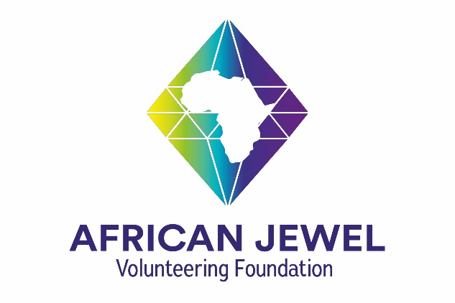

AJVF international inters and volunteers from all over the world to collaborate, assist and support with a variety of South Africans disadvantaged and physically challenged children (within some of the townships) in the northern areas of South Africa. The aim is to teach and improve their quality of life. This is done through ensuring their basic needs are met, education, and giving positive attention to get the children and communities to take responsibility by getting them to learn and know how to do it for themselves. The international volunteers will tackle tasks such as fundraising, campaigning, hosting events and collecting donations of clothing, food or money.